Look carefully around your school. Can you find these technology devices?

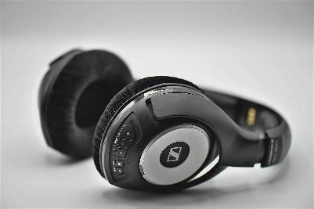
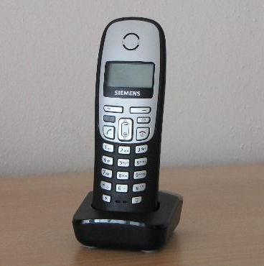

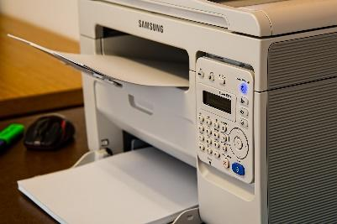
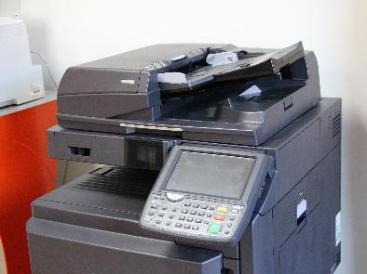
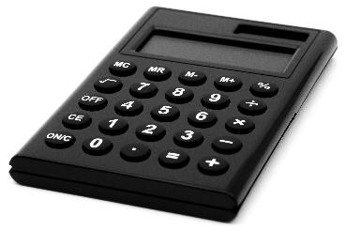
laptop
headphones
phone
calculator
copier
printer
Choose one piece of technology on your list.
Draw a picture to show what it is used for.
laptop
headphones
telephone
fire alarm
photocopier
printer
CD player
calculator
Choose one piece of technology on your list.
Draw a picture to show what it is used for.
Look carefully around your school. Can you find these technology devices?
The is used for…
The is used for…

Look carefully around your school. Where can you find these technology
devices? Can you think of other devices to add to the list?

laptop

headphones
telephone

fire alarm
photocopier

printer
CD player

calculator

burglar alarm
projector

